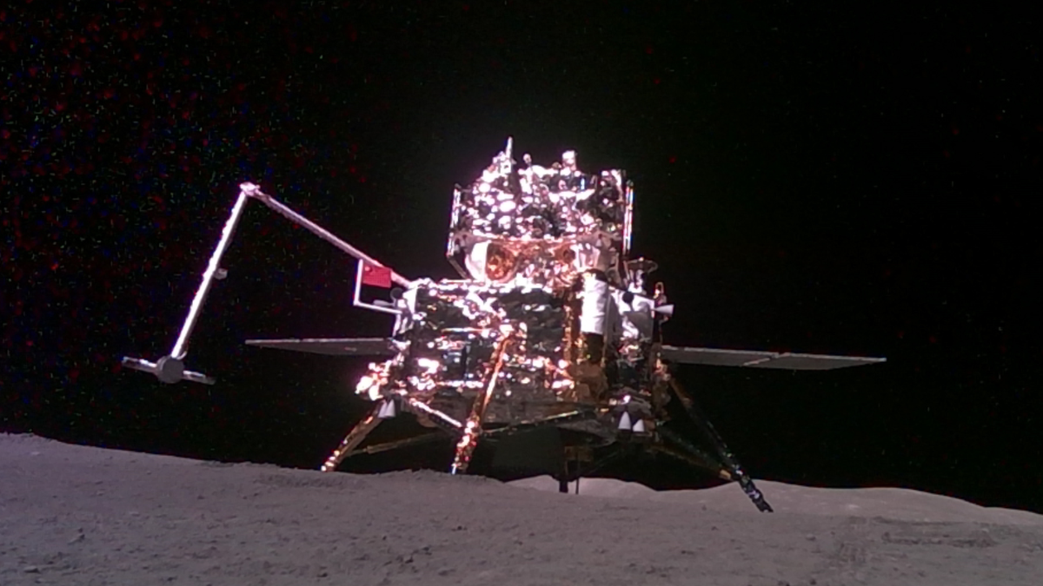

**Lunar rover simulation research**

31.01.2025

**By- Aryan Aman**

**Lead of research team**

**Team Lunarobotics**

Index

________________________________________  
 Stage 1: Mission & Arena Analysis  
  
The rover will be made to navigate through a 12m x 9m arena with obstacles and craters, performing autonomous tasks as commanded and returning to an exit point. The challenges replicate those actually encountered in planetary exploration: navigation, sample collection, and marker identification

**Arena Analysis**

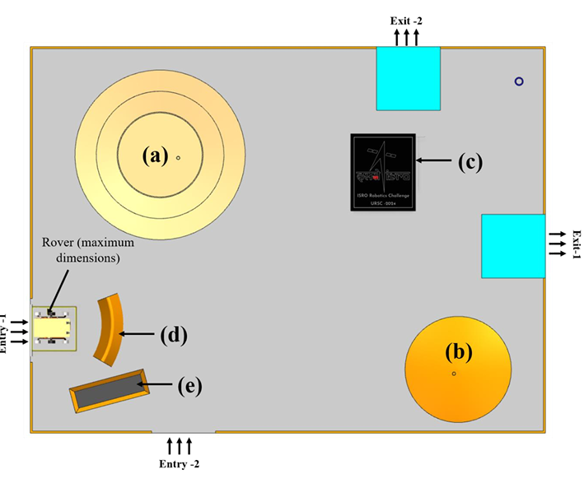  
1) **Arena Dimensions**: The size is **12m x 9m**, filled with **100mm M-sand**

2) **Key elements**

* **Crater**: 4m diameter, 200mm depth, slope <15°. (Traversable)
* **Hump**: 2.5m diameter, 260mm height, made of M-sand. (Traversable)
* **Hard Terrain**: Solid surface, level with M-sand height. (Traversable)
* **Wall**: Non-traversable, 0.8m height.
* **Slot**: Length 1.8m, width 0.6m, depth 100mm. (Traversable)

3)**Entry Points**: Two options available, Entry-1 gives more points but is more difficult. Both are **1.5m wide**.  
  
4)**Samples**: Three red samples at varying difficulty levels, which can be picked in any sequence.  
  
5)**Bonus Markers**: Star-shaped, randomly placed, colored, and numbered for identification.  
  
6)**Obstacles  
a)Traversable**: Random shapes/sizes, ≤150x150x150mm.  
**b)Non-Traversable**: Random shapes/sizes, ranging from 300x300x300mm to 800x800x800mm  
  
7)**Exit Points**: Two options, Exit-1 offers more points but is harder.  
  
8)**Boundaries**: Yellow-marked edges (200mm high) and white marks for entry/exit boxes.  
  
9)**Obstacle Placement**: All non-traversable obstacles will have at least **1m separation**.  
  
  
  
  
______________________________________________________________________________________________  
NOTE!!!  
The diagram is the revealed elements in the area and number and coordinates of traversable obstacles, non-traversable obstacles and craters will not be disclosed

______________________________________________________________________________________________

**Mission analysis**  
  
**Field task**  
**Task-1: Autonomous Navigation Task**

We are required to demonstrate the performance of rover’s navigation by traversing from entry point to sample collection point and subsequently to the container point and then exit from one of the identified locations. Rover can traverse in any path.

The teams are allowed to give maximum 4 commands if required in the total task at the following checkpoint which are as follows:  
 1. At the start of the task (at entry point-1 or 2)  
 2. After the drop of first sample  
 3. After the drop of second sample  
 4. After the drop of third sample **_____________________________________________________________________________________________________________**

### **1. Entry Task** Teams can choose between Entry-1 and Entry-2, where: + Entry-1 fetches more points but could be more challenging. + Entry-2 is easier but scores fewer points. Objective: Strategically decide the entry path based on rover capabilities.

### **2. Obstacle Identification Using Sensors** + Requirement: The rover’s sensors must:Detect dimensions of obstacles (height, width, and position). + Decide actions: Navigate around, over, or avoid the obstacles autonomously. Key Sensors: Ultrasonic sensor, thermal sensor or camera

### **3. Crater Identification Using Sensors** +Requirement: Sensors should: Detect and analyze the size (depth and diameter) of craters. Help the rover determine whether to navigate through, around, or avoid craters. + Key Sensors: Depth cameras or stereo vision sensors.

### **4. Sample Location Identification** Details: The rover must identify a red-colored sample with approximate dimensions Outer Diameter (OD): 80 mm. Length (L): 125 mm. Requirement:

Use vision-based sensors (camera with color detection) to locate the red sample.

Implement object recognition algorithms to confirm size and shape.

### **5. Container Location Identification** Details: A cylindrical container with: Diameter: 150 mm. Height: 150 mm. Requirement:

Identify the container’s location using cameras or sensors.

Precisely navigate to the container and recognize its dimensions to confirm it as the target.

**Task-2: Autonomous Sample Picking and Placing:**

### **Key Challenges:**

1. Target Identification (Tube Detection):
   * The rover must visually identify the red-colored hollow cylinder (ABS tube) lying on the surface.
2. Manipulator Arm Design:
   * A gripper system to securely pick up the tube without damaging or dropping it.
3. Mobility During Load:
   * The rover should be able to hold the tube securely during motion.
4. Placement Accuracy:
   * The tube needs to be dropped into a blue container with precision.

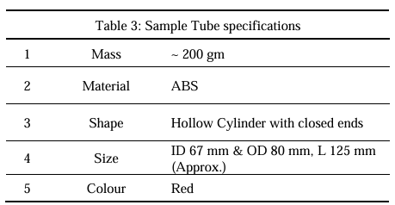

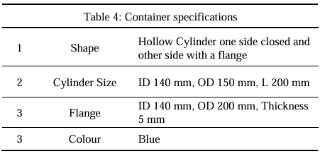

**Task-3: Repeat the Task-1 & Task-2 until all the samples are dropped in the sample container**

**Task-4: Identification of specific markers**

Identification of bonus targets includes the following:  
1. Capturing its images/shape with some sensor.   
2. All the bonus targets are marked with distinctive number and the team also needs to identify the number   
3. Coordinates of the particular bonus target to be identified with a variation of ± 0.5m

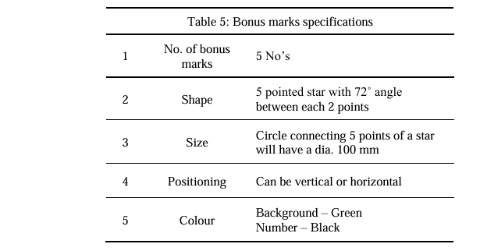  
The full marks for the identification of bonus marks will only be allotted if a proof of detection and allotted number are provided along with coordinates. However, a partial mark will be given if all the requirements are not satisfied.  **____________________________________________________________________________________________________  
Task time:**

Total time available to execute all the field tasks is 40 minutes and a 20 minutes slot will be provided for the team for setup their rover before the task.

______________________________________________________________________________________________  
  
  
  
________________________________________  
 Stage 2: Rover Performance Analysis

**Here we analyse our competitors rovers and extract useful information out of them as well as rovers made by space agencies**

**Sharda university rover**

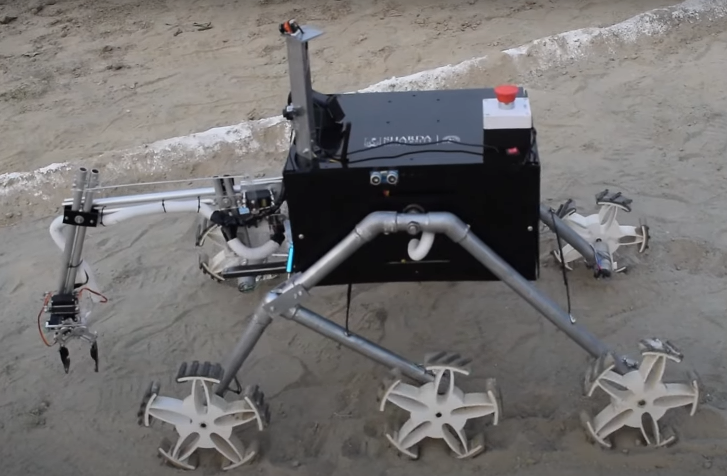

This is a very basic design but has lots of issues

1)Center of gravity is too high due to boxy design which makes the rover unstable, the CoG should be kept as low as possible to reduce risk of tipping over and high CoG also goes against wheels and they might slip when climbing a crater which will mess up the navigation system as well

2)The Rocker bogie suspension is too tightly fixed giving it less freedom and looks more rigid decreasing its obstacle clearing capabilities

3) The wheel design is flawed, the width of wheels arent enough which makes it more probable to sink in sand (the rover struggles navigating in sand in the presentation video), a wide and complete wheel design should be incorporated instead, may even go with balloon wheels than this.

4)The mechanical arms rest in a very odd position very near to ground sometimes even touching it and the arm seems very weak around the joints and the joints dont have sophisticated enough system to come on a position very precisely and efficiently but rather takes a hit and trial approach due it its primitive design and the gripping mechanism is awful as well with not enough grip strength and that is clearly seen when it drops the object it picked instantly

Some of its strengths are

1) A great integration of openCV to check for coloured tubes and live video feed and the team claims to have LiDAR which is really advanced if true

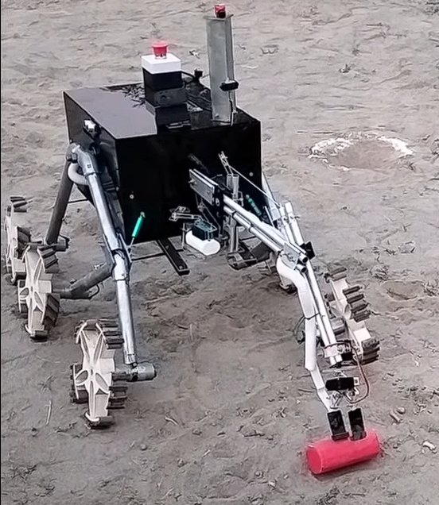

Struggling to align properly dragging the tube but not holding it

Also has a kill switch

**Team DHOOMKETU rover**

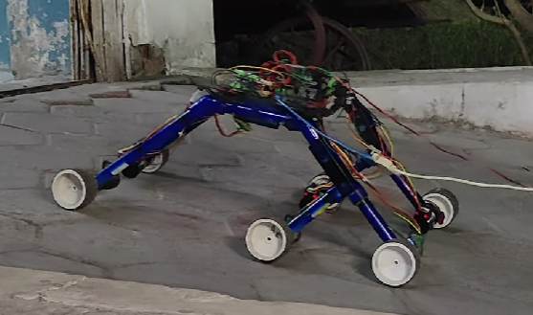

This rover again has some flaws (this design is prototype and we dont have finalised rover video in public)

1) The wheel seems too small which is not a good choice for a rover that needs to transverse obstacles, larger wheel provide a better approach angle so it rolls smoothly instead of straight up hitting them and also provide more stability

2) the electronics again seems to be high mounted which is not good for stability of rover

3) The rocker bogie system is also flawed, the angles are too low, its usually has a much larger angle in bogie side

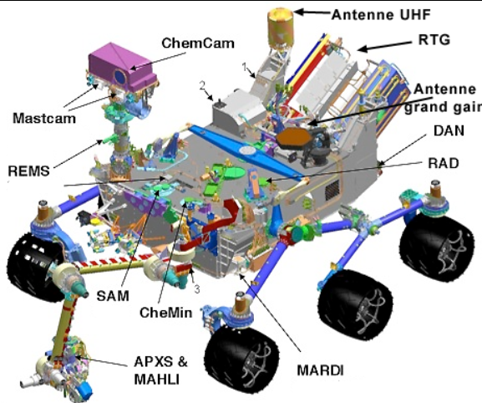

We can see a much higher angle between the two legs of bogie side and also a much lower center of gravity in curiosity rover which were missed by most of the rovers in the competition,

For the advantages, the software side is neatly done, it uses a LiDAR too and object detection and pathfinder software is really great

**Team SHUNYA rover**

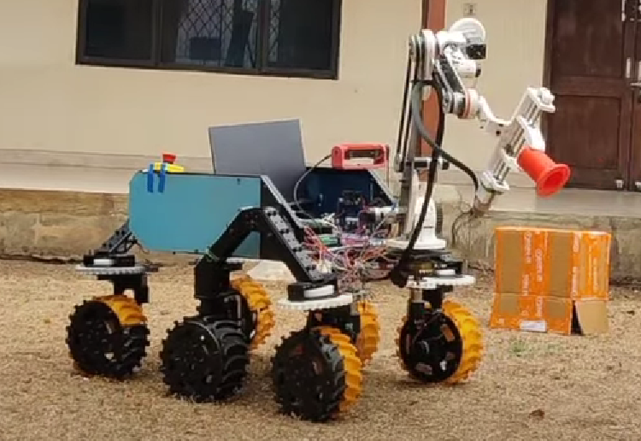

Great rover overall, bigger wheels, improvement over others, really good mechanical arm but has some flaws in the wheel structure, the rocker wheel is really unstable and seems to use 1 motor for 2 wheels transferring power by gear

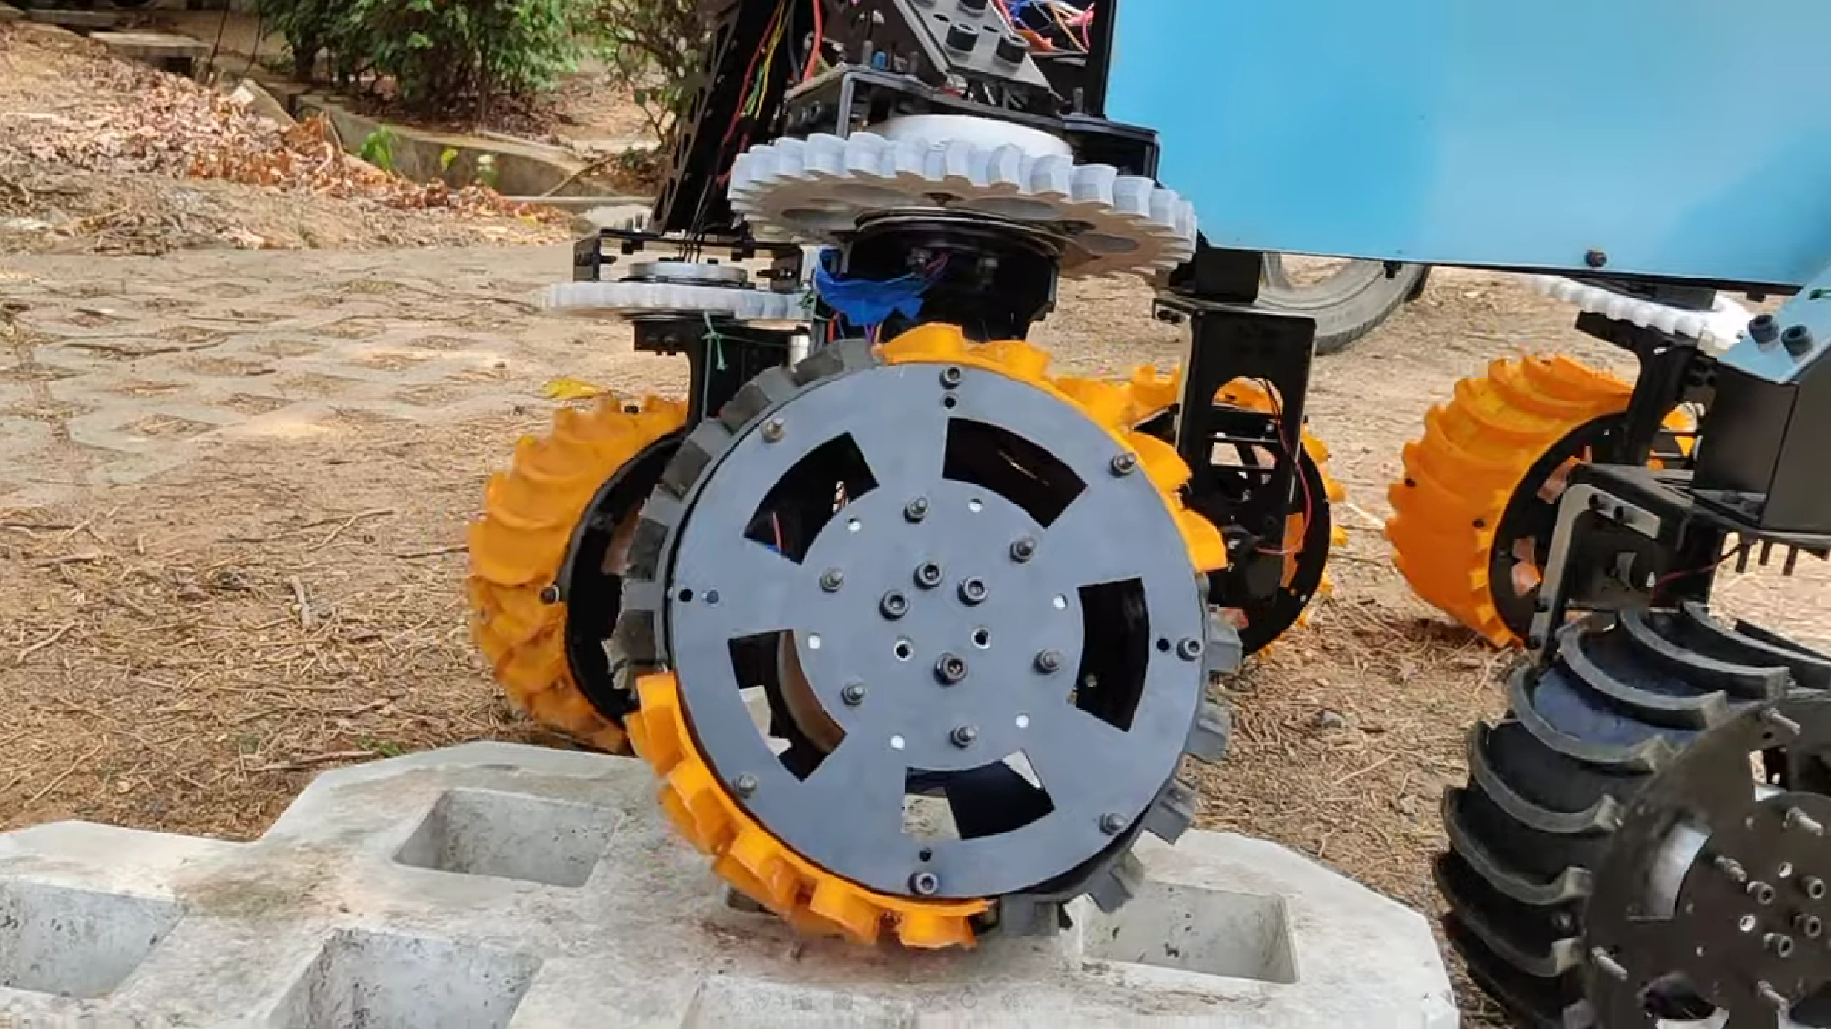  
  
  
**Team Talisha Space Research Organization**

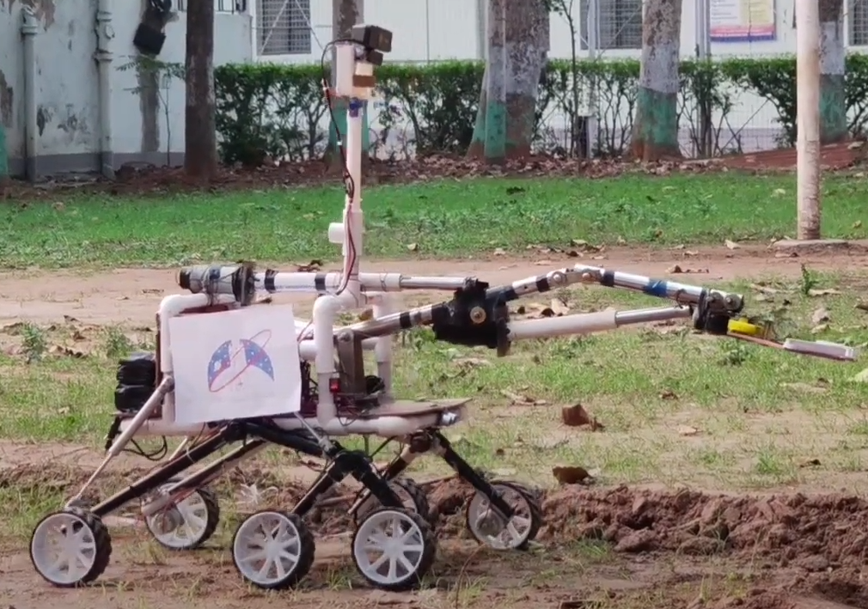

Loose wheels, its tilted so the wheel is with contact along a single line which is not good for sandy terrain and is gonna be stuck

The camera setup is really good with 360 degree rotatable axis

The structural integrity of rover is low, loose attachments and not good enough boxing of the electronics

The Arm looks not in good shape but works fine so it does its job.

**Team IISER Bhopal rover**

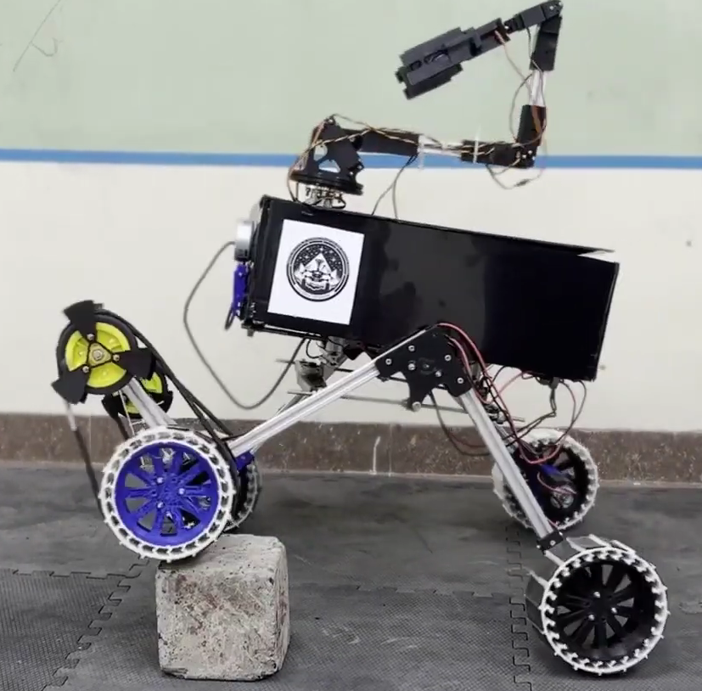

4 wheel design gives a disadvantage for traversing over obstacles

The CoG is gain really high, the system for running front wheels reduces its efficiency and the wheels slip on sand

Each movement and even the moving of robotic arm shakes the body (box) too much so too unstable of a rover it is.

No significant advantage found which can give them edge over other rovers

**Team Dhristi**  
  
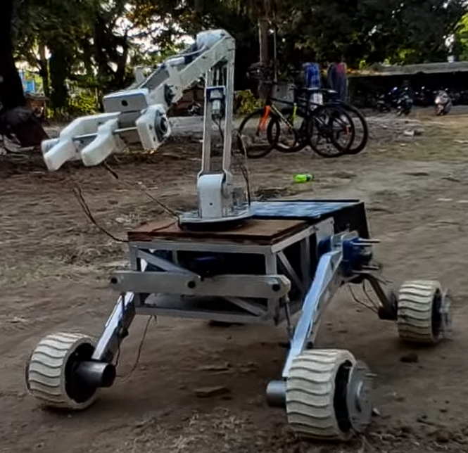

4 wheel setup is again worse and the arm joints are weak, they wobble in resting position increasing the

But this rover is the most stable one yet, the CoG is really good, the electronics box is low mounted, the arm is one the better ones with the stepper motor rod thing grabbing mechanism

And despite being 4 wheel structure it transverses the terrain fairly well

The wheels are broad enough and the rover has a kill switch

**_________________________________________________________________________________**  
**Stage 3) Improvement Proposal Challenge**

Taking from what we have learned yet we can proceed building and improving our own rover for the competition

Let's break down each operation in multiple sections and suggest possible design elements one by one

**1)Drive system**- we should go with a 6 wheel rocker bogie suspension drive system, and the frame made out of carbon fiber, each wheel having independent actuators.

The drive system would be direct drive system with independent control over each wheel

The wheels can be made from Thermoplastic Polyurethane 3d printed tires (or any other available material if needed) the wheel pattern should be Tread Pattern inspired by curiosity rover by nasa.

The motors should be Brushless DC motors for higher efficiency and wider speed range and control

The wheel should be broad, 20-30 cm diameter (the craters in the arena will be of 20cm depth so the radius at max cant exceed 20 cm of the axel and motor would rub against the ground), wheels with 8 cm to 12 cm wide grip length, this can be updated in future with prototype testing to see if it faces any difficulty doing sharp turns in front of obstacles etc.

**Improvement proposal**

Use of differential rod in rocker bogie mechanism, The mars rover curiosity uses a differential bar mechanism in rocker bogie system

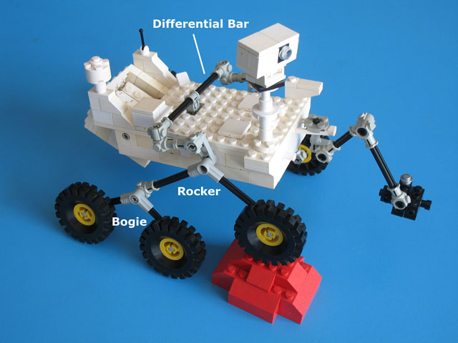

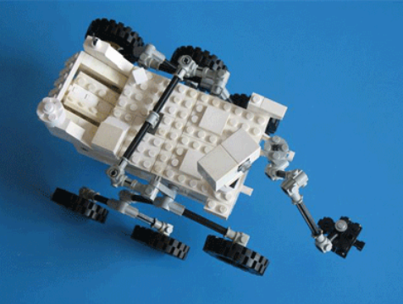

Or a differential gear using 3 bevel gear

More info [Here](https://alicesastroinfo.com/2012/07/mars-rover-rocker-bogie-differential/)

**2) Sensors:**

We would need a series of sensors for object detection, obstacle detection, and crater and hill finding

1. For navigation we can use a RGB camera with ultrasound sensors and depending on budget can even go for a depth camera
2. Crater detection could also be done by the above sensors
3. IMU could be a great integration for orientation and motion measurement
4. Radio modules for telemetry
5. Sensors to confirm mechanical arm is in position to pick up items (Ultrasound or IR)

**3) Control system:**The rover will use **Closed-Loop Control**: The arena is not fully shown and the rover is gonna have some errors so it should take continuous feedback and correct itself regularly based on its environment hence we choose a closed loop control over an open loop control